

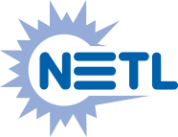

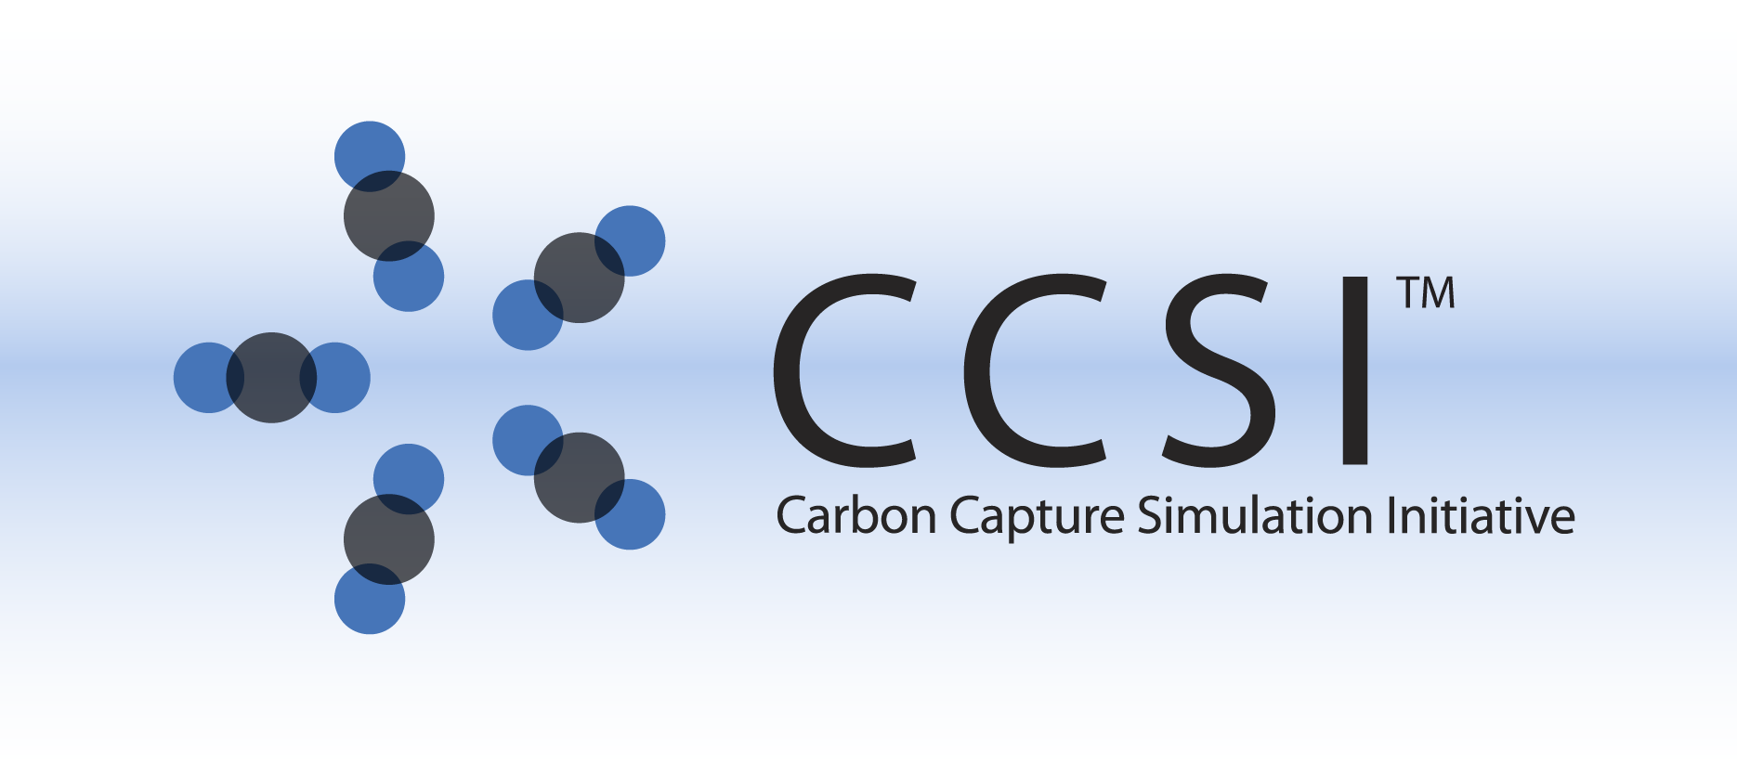

iREVEAL INSTALLATION GUIDE

Version 2.0.0

February 2018

Copyright (c) 2012 - 2018

**Copyright Notice**

iREVEAL was produced under the DOE Carbon Capture Simulation Initiative (CCSI), and is copyright (c) 2012 - 2018 by the software owners: Oak Ridge Institute for Science and Education (ORISE), Los Alamos National Security, LLC., Lawrence Livermore National Security, LLC., The Regents of the University of California, through Lawrence Berkeley National Laboratory, Battelle Memorial Institute, Pacific Northwest Division through Pacific Northwest National Laboratory, Carnegie Mellon University, West Virginia University, Boston University, the Trustees of Princeton University, The University of Texas at Austin, URS Energy & Construction, Inc., et al.. All rights reserved.

NOTICE. This Software was developed under funding from the U.S. Department of Energy and the U.S. Government consequently retains certain rights. As such, the U.S. Government has been granted for itself and others acting on its behalf a paid-up, nonexclusive, irrevocable, worldwide license in the Software to reproduce, distribute copies to the public, prepare derivative works, and perform publicly and display publicly, and to permit other to do so.

**License Agreement**

iREVEAL Copyright (c) 2012 - 2018, by the software owners: Oak Ridge Institute for Science and Education (ORISE), Los Alamos National Security, LLC., Lawrence Livermore National Security, LLC., The Regents of the University of California, through Lawrence Berkeley National Laboratory, Battelle Memorial Institute, Pacific Northwest Division through Pacific Northwest National Laboratory, Carnegie Mellon University, West Virginia University, Boston University, the Trustees of Princeton University, The University of Texas at Austin, URS Energy & Construction, Inc., et al. All rights reserved.

Redistribution and use in source and binary forms, with or without modification, are permitted provided that the following conditions are met:

1. Redistributions of source code must retain the above copyright notice, this list of conditions and the following disclaimer.
2. Redistributions in binary form must reproduce the above copyright notice, this list of conditions and the following disclaimer in the documentation and/or other materials provided with the distribution.
3. Neither the name of the Carbon Capture Simulation Initiative, U.S. Dept. of Energy, the National Energy Technology Laboratory, Oak Ridge Institute for Science and Education (ORISE), Los Alamos National Security, LLC., Lawrence Livermore National Security, LLC., the University of California, Lawrence Berkeley National Laboratory, Battelle Memorial Institute, Pacific Northwest National Laboratory, Carnegie Mellon University, West Virginia University, Boston University, the Trustees of Princeton University, the University of Texas at Austin, URS Energy & Construction, Inc., nor the names of its contributors may be used to endorse or promote products derived from this software without specific prior written permission.

THIS SOFTWARE IS PROVIDED BY THE COPYRIGHT HOLDERS AND CONTRIBUTORS "AS IS" AND ANY EXPRESS OR IMPLIED WARRANTIES, INCLUDING, BUT NOT LIMITED TO, THE IMPLIED WARRANTIES OF MERCHANTABILITY AND FITNESS FOR A PARTICULAR PURPOSE ARE DISCLAIMED. IN NO EVENT SHALL THE COPYRIGHT OWNER OR CONTRIBUTORS BE LIABLE FOR ANY DIRECT, INDIRECT, INCIDENTAL, SPECIAL, EXEMPLARY, OR CONSEQUENTIAL DAMAGES (INCLUDING, BUT NOT LIMITED TO, PROCUREMENT OF SUBSTITUTE GOODS OR SERVICES; LOSS OF USE, DATA, OR PROFITS; OR BUSINESS INTERRUPTION) HOWEVER CAUSED AND ON ANY THEORY OF LIABILITY, WHETHER IN CONTRACT, STRICT LIABILITY, OR TORT (INCLUDING NEGLIGENCE OR OTHERWISE) ARISING IN ANY WAY OUT OF THE USE OF THIS SOFTWARE, EVEN IF ADVISED OF THE POSSIBILITY OF SUCH DAMAGE.

You are under no obligation whatsoever to provide any bug fixes, patches, or upgrades to the features, functionality or performance of the source code ("Enhancements") to anyone; however, if you choose to make your Enhancements available either publicly, or directly to Lawrence Berkeley National Laboratory, without imposing a separate written license agreement for such Enhancements, then you hereby grant the following license: a non-exclusive, royalty-free perpetual license to install, use, modify, prepare derivative works, incorporate into other computer software, distribute, and sublicense such enhancements or derivative works thereof, in binary and source code form. This material was produced under the DOE Carbon Capture Simulation Initiative

Table of Contents

1. Introduction 1

2. Prerequisites 1

2.1. Hardware 1

2.2. Software 1

2.2.1. Software packages for integrating ROM in Aspen Plus Simulation: 1

3. Basic Installation 1

3.1. Third Party Software Installation 1

3.1.1 Java installation 1

3.1.2 Aspen Installation 2

Follow AspenTech’s installation guide to install ACM and Aspen Plus version 9 or higher. 2

3.2. Product Build (For Developers Only) 2

3.3. Product Installation 2

4. Installation Test 2

5. Installation Problems 3

5.1. Known Issues/Fixes 3

5.2. Reporting Installation issues 3

# Introduction

iREVEAL framework is a toolkit for reduced order modeling of scientific simulations. It has been developed under Carbon Capture Simulation Initiative for response surface generation of Computational Fluid Dynamics(CFD) models and can be used for MFIX(Multiphase Flow with Interphase Exchanges) Barracuda, Fluent or any other CFD model. However it is a generic framework and can be customized for use in other domains easily as well.

# Prerequisites

## Hardware

N/A

## Software

iREVEAL has been tested on 32 bit and 64 bit windows platform and Ubuntu 64 bit Linux platform. iREVEAL requires the Java Runtime Environment to run the executable and Java Development Kid (JDK) to compile the Java source code. The main C++ code can be compiled on Windows with Visual Studio and g++ on Linux. The list of software needed for the install is provided in Table 1.

Note: Users are expected to run their own CFD simulations

|  |  |  |
| --- | --- | --- |
| **Package** | **Online Installation Link** | **Version required** |
| 1. Java | Oracle.org | 1.6 or higher |

Table 1: Getting Required Packages

## Software packages for integrating ROM in Aspen Plus Simulation:

To integrate a iREVEAL generated reduced order model in Aspen Plus for process simulation user needs following software:

1. Aspen Plus version 9 or higher
2. Aspen ACM version 9 or higher

# Basic Installation

## Third Party Software Installation

### 3.1.1 Java installation

To use iREVEAL, user needs to have java version 6 (**java -1.7)** or higher installed on the system. To check if java is installed, open command line and on prompt check for java version, you should get appropriate response listing java version. For e.g.,

* java -version

java version 1.7.x.x <build 1.6.x.x>

Java(SE) TM Runtime Environment

If JDK/JRE is not already installed, please install appropriate 32bit or 64 bit JRE

(download link- http://www.oracle.com/technetwork/java/javase/downloads/index.html)

### 3.1.2 Aspen Installation

### Follow AspenTech’s installation guide to install ACM and Aspen Plus version 9 or higher.

## Product Build (For Developers Only)

Most users need not perform this step. User can download the iREVEAL installer directly from CCSI product page and skip section 3.2.

To build iReveal jar file directly from source, the user may follow the instructions below:

1. Checkout the iREVEAL code from our Github site
2. Ensure you have JDK( Java Development Kit) installed (not just JRE)
3. Change directory “Java” folder. Run script “make_ireveal_jar.bat” on Windows or “make_ireveal_jar.sh” on Linux. It will create a jar file name “iReveal.jar”

To build C++ executable file iReveal.exe, the user may follow the instructions below:

On Windows, open “iReveal.sln” file in Visual Studio and run “Build” command. The executable file will be in the “Release” folder.

On Linux, change directory to “iReveal” and run command “make”. An executable file iReveal will be created in the same directory.

## Product Installation

IREVEAL is a command line based product. The binary executable code contains only two files “iReveal.jar” and “iReveal.exe” (Windows) or “iReveal” (Linux), which can be built as discussed in Section 2. To install the software, simply copy the two files and paste to a directory on your Windows or Linux machine (They have to be in the same directory). You can use that directory to run the commands. If you want to run it in any directory, please add that directory to your PATH environmental variable.

For the Linux user, usually “.profile” in user’s home directory needs to be edited to add the directory of other two too files to the $PATH environmental variable. Also make sure “export PATH=.:$PATH” is included in the “.profile” file such that the executable “iReveal” can be run without adding “./” before the command.

The user does not need to change CLASSPATH environmental variable as long as the “iReveal.jar” file is in the same directory as the executable file.

# Installation Test

To test iREVEAL installation, open a DOS window and type iReveal.exe –v. The version number will be printed to the screen. On Linux, type ./iReveal –v.

# Installation Problems

## Known Issues/Fixes

## Reporting Installation issues

Contact [ccsi-support@acceleratecarboncapture.org](mailto:ccsi-support@acceleratecarboncapture.org).

The email of lead development team for this product are :

[Jinliang.Ma@netl.gov](mailto:Jinliang.Ma@netl.gov),